**MOBILE APPLICATION DEVELOPMENT**

**Final Lab Exam**

**Your Name: Phạm Đức Đạt**

**Your ID: ITITIU20184**

**Due date:** Please check on Blackboard

**Instruction**

Please follow the steps:

1. For each question, please make your code clean and make sure that your code is runnable.
2. Web searching is NOT allowed.
3. Open the provided problem sets (.docx file). For each exercise, please capture full-page screenshots of your work and then paste them into the problem sets (.docx file). DO NOT create a new answer file!

Please convert this .docx file to .pdf file

1. Submit these files (source code and problem set files) to Blackboard before the deadline.
2. There are a total of 9 Lab Assignments in this course. 3/9 Lab Assignments will be randomly selected to score (~10% of your final score).
3. The final lab exam will be 10% of your final score.

**Lab Assignments**

**Basic Part: (60 points)**

Create Two-Activity Calculator App, a simple calculator which can perform basic arithmetic operations like addition, subtraction, multiplication, or division depending upon the user input.

- A TextView to display the function.

- A TextView to display the calculation result.

- C button to delete the input only.

- AC button to clear all (including the function and the calculation result).

**Advanced Part: History Activity (20 points)**

* Create a new activity (HistoryActivity) to display the history of calculations.
* The history should show past input expressions and results.
* Users should be able to clear the history.

Figure 1. Basic calculator

**Basic Part: (60 points)**

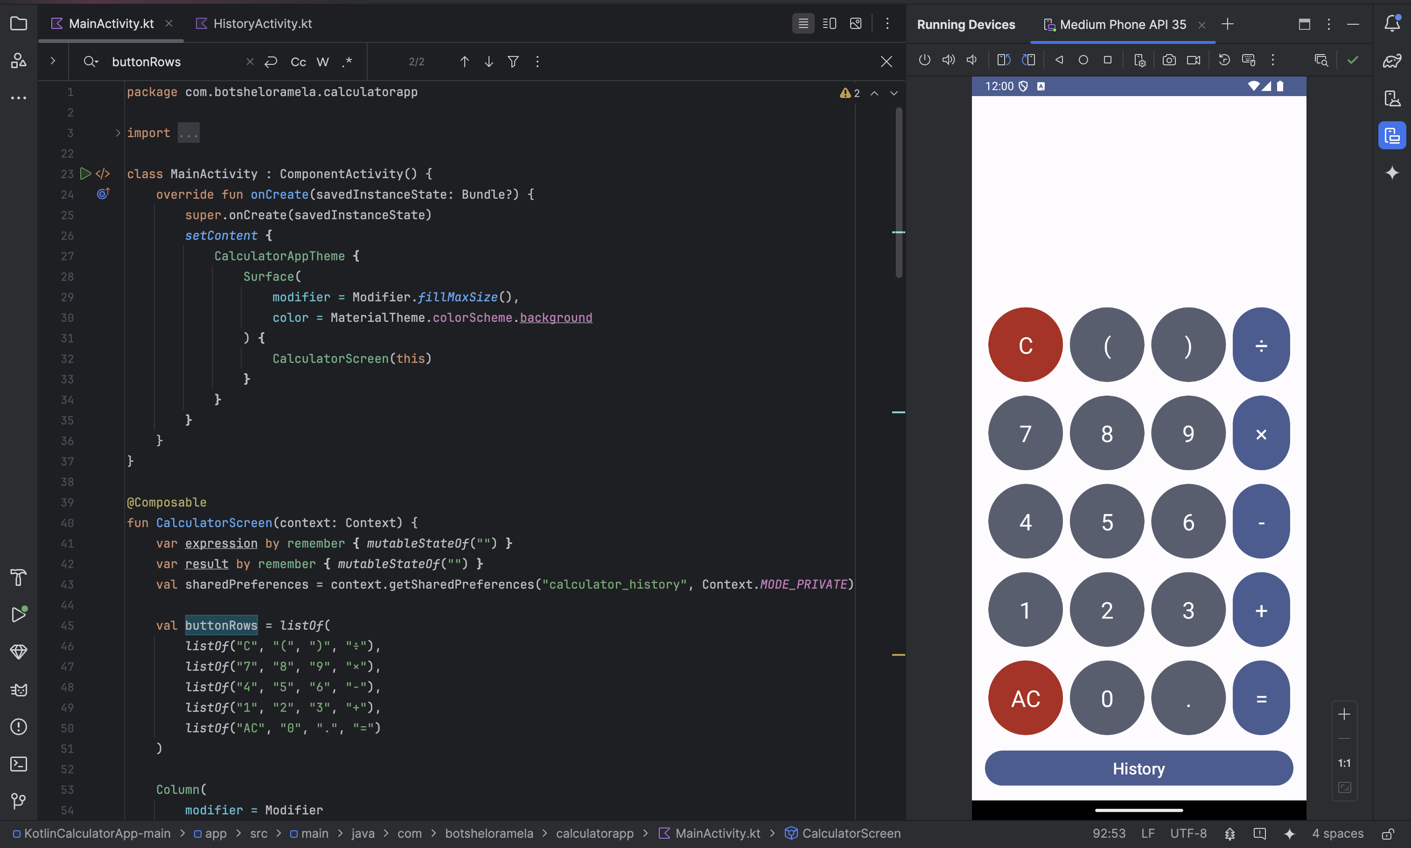

**Advanced Part: History Activity (20 points)**

Clear history

